8th Macclesfield Scout Group
Income & Expenditure Account
For the period: | 2025/26 | 2024/25 | Variance
From | 01-Apr | 01-Apr | Variance
To | 31st March | 31st March | Variance
Income
Subscriptions | 4512.50 | 3,591.50 | 921.00
Joining Fees | 0.00 | 0.00 | 0.00
Subs in Advance | 0.00 | 0.00 | 0.00
Activity Fees | 734.00 | 0.00 | 734.00
Camp Fees | 1589.00 | 150.00 | 1,439.00
Donations | 83.00 | 0.00 | 83.00
Grants | 0.00 | 0.00 | 0.00
Fund Raising | 105.00 | 0.00 | 105.00
Gift Aid | 669.47 | 1,160.07 | -490.70
Scout shop | 133.00 | 0.00 | 133.00
Total Income | 7,825.97 | 4,901.57 | 2,924.40
Expenditure
Capitation | 2289.50 | 1,134.00 | 955.50
Insurance | 166.00 | 332.00 | -166.00
Room Hire | 900.00 | 1,162.50 | -262.50
Scout Shop | 587.43 | 250.98 | 336.45
Meeting Resources | 223.20 | 0.00 | 223.20
Activity Costs | 1648.96 | 723.98 | 924.98
Camp Costs | 1649.14 | 607.50 | 1,041.64
Equipment | 267.00 | 103.50 | 163.50
Training | 0.00 | 0.00 | 0.00
Administration | 0.00 | 0.00 | 0.00
Bank Charges | 5.00 | 0.00 | 0.00
Other | 346.50 | 0.00 | 346.50
 |  |  | 0
Total Payments | 8,082.73 | 4,514.46 | 3,568.27
Net Surplus / (Deficiency) | -256.76 | 387.11 | -643.87
BALANCE SHEET
As At | 31st March | 31st March | Variance
Assets
Fixed Assets and Equipment | 1500.00 | 1,500.00 | 0.00
 |  |  | 0
Debtors & Prepayments | 0.00 | 0.00 | 0.00
Cash in Hand:
Beavers | 0.00 | 0.00 | 0.00
Cubs | 0.00 | 0.00 | 0.00
Scouts | 0.00 | 0.00 | 0.00
Group | 0.00 | 0.00 | 0.00
Current Account | 1482.41 | 1,739.17 | -256.76
Deposit Account | 0.00 | 0.00 | 0.00
Total cash & Deposits | 1,482.41 | 1,739.17 | -256.76
Total Assets | 2,982.41 | 3,239.17 | -256.76
Liabilities
Subscriptions Received in advance | 0.00 | 0.00 | 0.00
Creditors & Accruals | 0.00 | 0.00 | 0.00
Total Liabilities | 0.00 | 0.00 | 0.00
Net Asset and Liabilities | 0.00 | 3,239.17 | -256.76
Represented by:
Opening Reserves as at 31st March | 3239.17 | 2,852.06 | 387.11
Income & Expenditure Account: Surplus / (Loss) | -256.76 | 387.11 | -643.87
Reserves Carried Forward | 2,982.41 | 3,239.17 | -256.76
 | The above income and expenditure account and Balance sheet were approved by the Trustees on the 13/4/2026 and signed on their behalf by
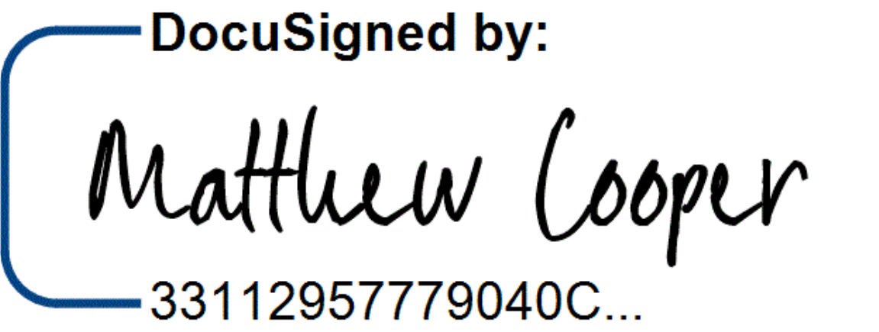 |  | Matthew Cooper Chair
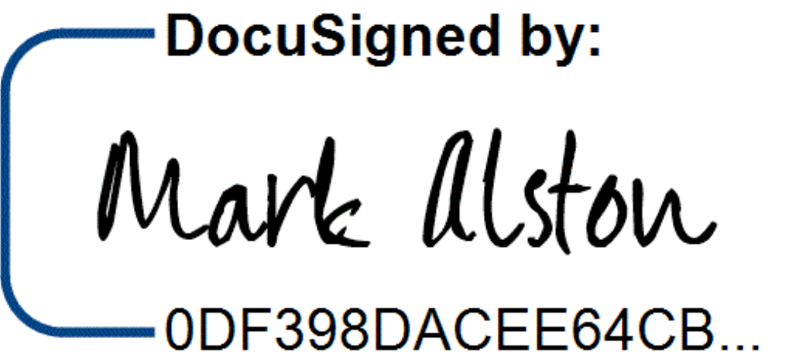 |  | Mark Alston Treasurer

